## Custom Base Map Provider

You can also add your own custom map provider. It is disabled by default and to change it go on Properties palette in the **Base map** section open **Provider** selection dropdown, click **More providers…**. On bottom of the list check **Custom ArcGIS Service** and press Save button. Now on **Provider** selection dropdown click on **Custom ArcGIS Service** which will open a new window where you can enter your custom map provider **Service address**. Press **Get Details** button and if your service address is valid, you can save it and/or add it to bookmarks.

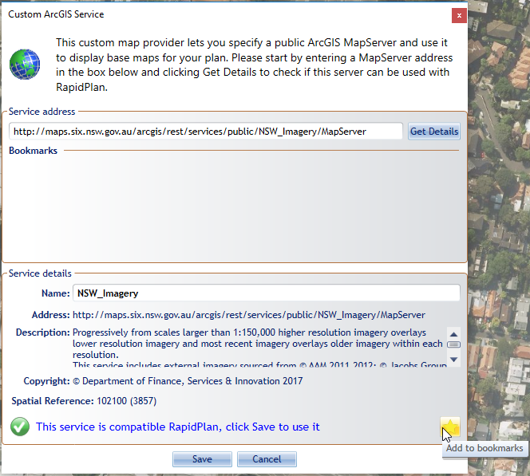

Custom_ArcGIS_Service

## Custom Base Map Provider Requirements

* RapidPlan version >= 3.2
* Supported data formats: standard World File, MapInfo raster .TAB file
* Spatial reference: ESRI 102100/3857 (Web Mercator)